How to Upload the APK and Run It Online
Oct 30, 2026 · @Andrea Wafula awongoma@usiu.ac.ke

Part 1: Get the APK onto the computer
The built app is a file called app-debug.apk

(THIS IS IN GITHUB. I HAVE SHARED THE app-debug.apk FILE VIA EMAIL. USE THAT ONE)
If you annot acces it/want to do it on your side using instructions below, use Username: awongoma@usiu.ac.ke and Password: 671714.ab
Inside the Code (Green Button) -> Codespace, and it must be downloaded before it can be uploaded anywhere.
- In the Codespace's Explorer, open app, then build, then outputs, then apk, then debug.
- In the terminal, run gradle assembleDebug
- Right-click app-debug.apk and choose Download.
- Open the browser's Downloads (Ctrl + J) to confirm it saved.
(THIS IS IN GITHUB. I HAVE SHARED THE app-debug.apk FILE VIA EMAIL. USE THAT ONE)

Part 2: Upload it to an online emulator
Appetize.io (https://www.bing.com/ck/a?!&&p=cbdd7ad25bfa93af151d22cd3fcf50839c820ad21567f12e5ee6442c58ce2ad3JmltdHM9MTc5MzMxODQwMA&ptn=3&ver=2&hsh=4&fclid=323e2af4-d911-6435-0d00-32f6d81f658d&psq=appetize.io&u=a1aHR0cHM6Ly9hcHBldGl6ZS5pby8) is the first choice; ApkOnline is the backup. Appetize's screens were not checked, so button names may differ slightly, and its free tier has limited streaming minutes. Have your test numbers ready before starting a session.
Appetize.io
- Go to appetize.io and sign up for a free account. You may need one before you can upload.
- Find the upload option, usually a drag-and-drop box or an "Upload" or "Add app" button.
- Drag app-debug.apk into it, or click and pick the file. Choose Android if it asks for the platform.
- When processing finishes, click Run or open the app link. A phone appears in the browser and your app launches.
ApkOnline (backup)
- Open apkonline.net. It is free and shows ads, and it runs an older Android (8.0), which is fine for these screens.
- Click Run on a phone.
- Upload the APK from its file panel.

Taking screenshots
I have also sent some screenshots of the application to you via email. Review them and dd or delete the ones you wish to.

Press Win + Shift + S on the computer, drag over the phone area, and paste the capture into a Word document.
For CAT One, capture three things:
- the main screen showing a Maximum result
- the main screen showing a Minimum result
- the second activity showing the two values

If the upload fails or the app crashes
If the upload is rejected, note exactly what the screen says and try the backup emulator. If the app crashes on launch, that usually means a bug in the code, so send the exact message or a screenshot and the project files can be fixed.

What’s in the project
Question part | Where it’s answered
(i) TableLayout interface | activity_main.xml
(ii) Declare and bind widgets | the top of onCreate in MainActivity.java
(iii) Maximum and Minimum click events | the btnMax and btnMin listeners in MainActivity.java
(iv-a) Jump to the second activity | the btnNext listener (Intent and startActivity)
(iv-b) Send and show min and max | putExtra in MainActivity.java, getIntExtra in Second.java

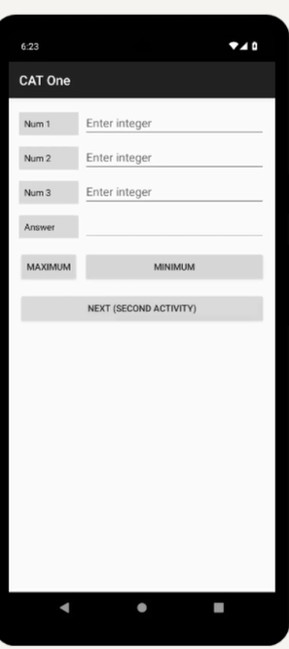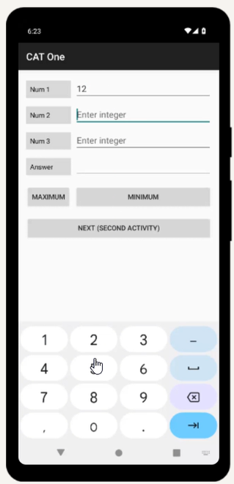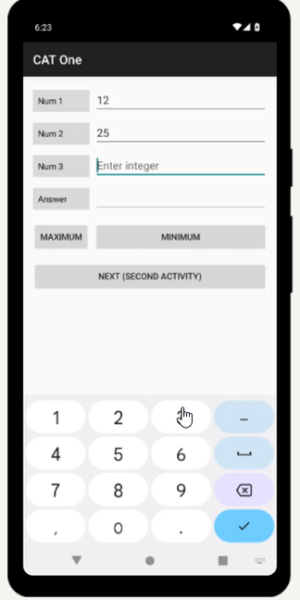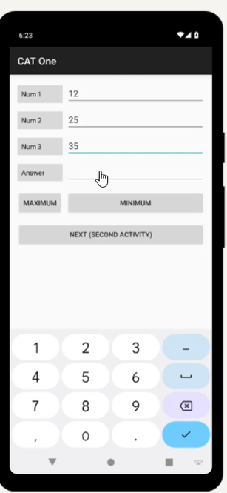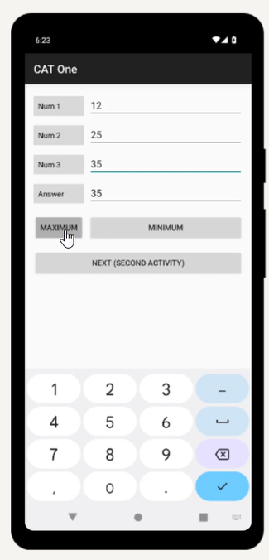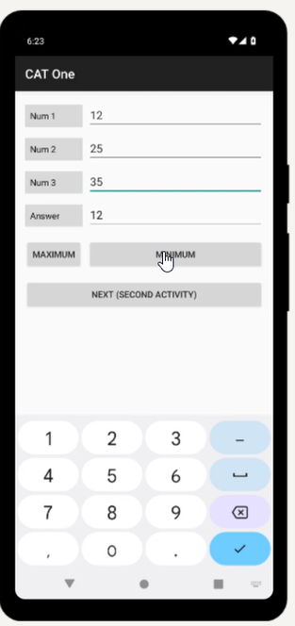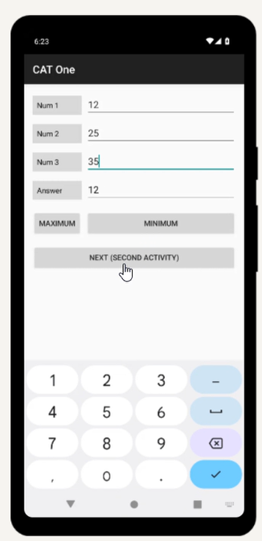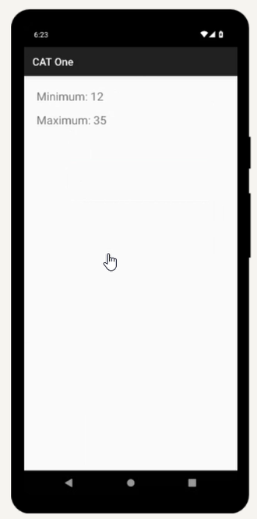

Use the table layout to write xml code that will produce the interface shown. (5 marks)
<?xml version="1.0" encoding="utf-8"?>
<!-- (i) TableLayout producing the interface in the question -->
<TableLayout xmlns:android="http://schemas.android.com/apk/res/android"
android:layout_width="match_parent"
android:layout_height="match_parent"
android:padding="16dp"
android:stretchColumns="1">

<!-- Row 1: Num 1 -->
<TableRow
android:layout_width="match_parent"
android:layout_height="wrap_content"
android:layout_marginBottom="8dp">

<TextView
android:id="@+id/tvNum1"
android:layout_width="wrap_content"
android:layout_height="wrap_content"
android:background="#D9D9D9"
android:padding="8dp"
android:text="Num 1"
android:textColor="#000000" />

<EditText
android:id="@+id/etNum1"
android:layout_width="match_parent"
android:layout_height="wrap_content"
android:layout_marginLeft="8dp"
android:hint="Enter integer"
android:inputType="numberSigned" />
</TableRow>

<!-- Row 2: Num 2 -->
<TableRow
android:layout_width="match_parent"
android:layout_height="wrap_content"
android:layout_marginBottom="8dp">

<TextView
android:id="@+id/tvNum2"
android:layout_width="wrap_content"
android:layout_height="wrap_content"
android:background="#D9D9D9"
android:padding="8dp"
android:text="Num 2"
android:textColor="#000000" />

<EditText
android:id="@+id/etNum2"
android:layout_width="match_parent"
android:layout_height="wrap_content"
android:layout_marginLeft="8dp"
android:hint="Enter integer"
android:inputType="numberSigned" />
</TableRow>

<!-- Row 3: Num 3 -->
<TableRow
android:layout_width="match_parent"
android:layout_height="wrap_content"
android:layout_marginBottom="8dp">

<TextView
android:id="@+id/tvNum3"
android:layout_width="wrap_content"
android:layout_height="wrap_content"
android:background="#D9D9D9"
android:padding="8dp"
android:text="Num 3"
android:textColor="#000000" />

<EditText
android:id="@+id/etNum3"
android:layout_width="match_parent"
android:layout_height="wrap_content"
android:layout_marginLeft="8dp"
android:hint="Enter integer"
android:inputType="numberSigned" />
</TableRow>

<!-- Row 4: Answer -->
<TableRow
android:layout_width="match_parent"
android:layout_height="wrap_content"
android:layout_marginBottom="16dp">

<TextView
android:id="@+id/tvAnswer"
android:layout_width="wrap_content"
android:layout_height="wrap_content"
android:background="#D9D9D9"
android:padding="8dp"
android:text="Answer"
android:textColor="#000000" />

<EditText
android:id="@+id/etAnswer"
android:layout_width="match_parent"
android:layout_height="wrap_content"
android:layout_marginLeft="8dp"
android:enabled="false"
android:inputType="none"
android:textColor="#000000" />
</TableRow>

<!-- Row 5: Maximum and Minimum buttons -->
<TableRow
android:layout_width="match_parent"
android:layout_height="wrap_content">

<Button
android:id="@+id/btnMax"
android:layout_width="wrap_content"
android:layout_height="wrap_content"
android:text="Maximum" />

<Button
android:id="@+id/btnMin"
android:layout_width="wrap_content"
android:layout_height="wrap_content"
android:layout_marginLeft="8dp"
android:text="Minimum" />
</TableRow>

<!-- Row 6: extra button used for part (iv) to jump to the second activity -->
<TableRow
android:layout_width="match_parent"
android:layout_height="wrap_content"
android:layout_marginTop="16dp">

<Button
android:id="@+id/btnNext"
android:layout_width="wrap_content"
android:layout_height="wrap_content"
android:layout_span="2"
android:text="Next (Second Activity)" />
</TableRow>

</TableLayout>
Write click events for each of the buttons that will display the Maximum and the minimum respectively.
(5 marks)

(MainActivity.java)
package com.example.catone;
import android.content.Intent;
import android.os.Bundle;
import android.view.View;
import android.widget.Button;
import android.widget.EditText;
import android.widget.Toast;
import androidx.appcompat.app.AppCompatActivity;
public class MainActivity extends AppCompatActivity {
// (ii) Declare the widgets
EditText etNum1, etNum2, etNum3, etAnswer;
Button btnMax, btnMin, btnNext;
@Override
protected void onCreate(Bundle savedInstanceState) {
super.onCreate(savedInstanceState);
setContentView(R.layout.activity_main);
// (ii) Bind the widgets to the ids in the XML layout
etNum1 = findViewById(R.id.etNum1);
etNum2 = findViewById(R.id.etNum2);
etNum3 = findViewById(R.id.etNum3);
etAnswer = findViewById(R.id.etAnswer);
btnMax = findViewById(R.id.btnMax);
btnMin = findViewById(R.id.btnMin);
btnNext = findViewById(R.id.btnNext);
// (iii) Click event: display the Maximum
btnMax.setOnClickListener(new View.OnClickListener() {
@Override
public void onClick(View v) {
int[] nums = readNumbers();
if (nums == null) return;
int max = Math.max(nums[0], Math.max(nums[1], nums[2]));
etAnswer.setText(String.valueOf(max));
}
});
// (iii) Click event: display the Minimum
btnMin.setOnClickListener(new View.OnClickListener() {
@Override
public void onClick(View v) {
int[] nums = readNumbers();
if (nums == null) return;
int min = Math.min(nums[0], Math.min(nums[1], nums[2]));
etAnswer.setText(String.valueOf(min));
}
});
// (iv-a) Jump to the second activity, (iv-b) sending the minimum and maximum
btnNext.setOnClickListener(new View.OnClickListener() {
@Override
public void onClick(View v) {
int[] nums = readNumbers();
if (nums == null) return;
int max = Math.max(nums[0], Math.max(nums[1], nums[2]));
int min = Math.min(nums[0], Math.min(nums[1], nums[2]));
Intent intent = new Intent(MainActivity.this, Second.class);
intent.putExtra("MIN_VALUE", min);
intent.putExtra("MAX_VALUE", max);
startActivity(intent);
}
});
}
// Reads the three inputs. Returns null (with a Toast) if any is missing or invalid.
private int[] readNumbers() {
String s1 = etNum1.getText().toString().trim();
String s2 = etNum2.getText().toString().trim();
String s3 = etNum3.getText().toString().trim();
if (s1.isEmpty() || s2.isEmpty() || s3.isEmpty()) {
Toast.makeText(this, "Please enter all three numbers", Toast.LENGTH_SHORT).show();
return null;
}
try {
return new int[]{
Integer.parseInt(s1),
Integer.parseInt(s2),
Integer.parseInt(s3)
};
} catch (NumberFormatException e) {
Toast.makeText(this, "Please enter valid integers", Toast.LENGTH_SHORT).show();
return null;
}
}
}

iv. Assuming that the student has added another activity to this application with java file named second.java
and xml file named second.xml, write code that will:
a. Enable the student to jump from the first activity to the second activity. (3 marks)
b. Send and display the values of minimum and maximum on two separate textviews on the
second activity. (4 marks)

(Second.java)
package com.example.catone;
import android.content.Intent;
import android.os.Bundle;
import android.widget.TextView;
import androidx.appcompat.app.AppCompatActivity;
// (iv) Second activity: receives the minimum and maximum and shows them in two TextViews
public class Second extends AppCompatActivity {
TextView tvMinimum, tvMaximum;
@Override
protected void onCreate(Bundle savedInstanceState) {
super.onCreate(savedInstanceState);
setContentView(R.layout.second);
tvMinimum = findViewById(R.id.tvMinimum);
tvMaximum = findViewById(R.id.tvMaximum);
Intent intent = getIntent();
int min = intent.getIntExtra("MIN_VALUE", 0);
int max = intent.getIntExtra("MAX_VALUE", 0);
tvMinimum.setText("Minimum: " + min);
tvMaximum.setText("Maximum: " + max);
}
}

(Second.xml)
<LinearLayout xmlns:android="http://schemas.android.com/apk/res/android" android:layout_width="match_parent" android:layout_height="match_parent" android:orientation="vertical" android:padding="24dp">
<TextView android:id="@+id/tvMinimum" android:layout_width="match_parent" android:layout_height="wrap_content" android:layout_marginBottom="16dp" android:textSize="22sp"/>
<TextView android:id="@+id/tvMaximum" android:layout_width="match_parent" android:layout_height="wrap_content" android:textSize="22sp"/>
</LinearLayout>

